War, Morality, and the Military Profession: Second Edition
By Malham M. Wakin

Overview
This anthology brings together material on two major related topics: the military profession, and morality and war. The revised and updated edition retains those sections that made the original version indispensable in the classroom, while incorporating new selections on topics of special concern for the 1980s and beyond. In particular, Colonel Wakin has included essays focusing on the relevance of nuclear deterrence and just war theory in the nuclear age. More than a third of the chapters are new. The articles in the first section stress the ethical dimensions of the military profession, considering topics such as the conflict between military values and societal norms, the relation of the military to the state, and the concepts of loyalty, honor, and integrity. New chapters include an essay by Vice Admiral James B. Stockdale suggesting how moral philosophy can serve the profession, contemporary commentaries on the profession by Jacques Barzun and Max Lerner, and new thoughts on ethics and leadership by Colonel Wakin. The essays in Part 2 confront the agonizing moral issues associated with warfare, especially modern warfare. In conjunction with discussions of the laws of war and war crimes, new chapters highlight the continuing debate on nuclear issues. Included are excerpts from the U.S. Catholic Bishops' pastoral letter, The Challenge of Peace: God's Promise and Our Response; a defense of pacifism by Stanley Hauerwas; arguments about the use of nuclear weapons and nuclear deterrence by Michael Walzer, Michael Novak, and Charles Krauthammer; and some moral reflections on the Strategic Defense Initiative (Star Wars) by Kenneth Kemp.
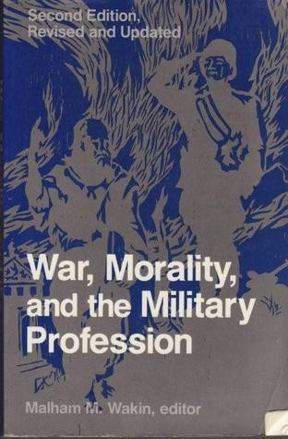
Home♦ Contact Us♦ Sitemap♦ Privacy Statement♦ External Links Disclaimer♦ U.S. Army
Bldg 621 Wilson Rd., Rm 118, West Point, NY 10996 ♦ Phone: (845) 938-0467 ♦ Fax: (845) 938-0414
An Official U.S. Army Site
Last Updated: December 6, 2012 9:02

